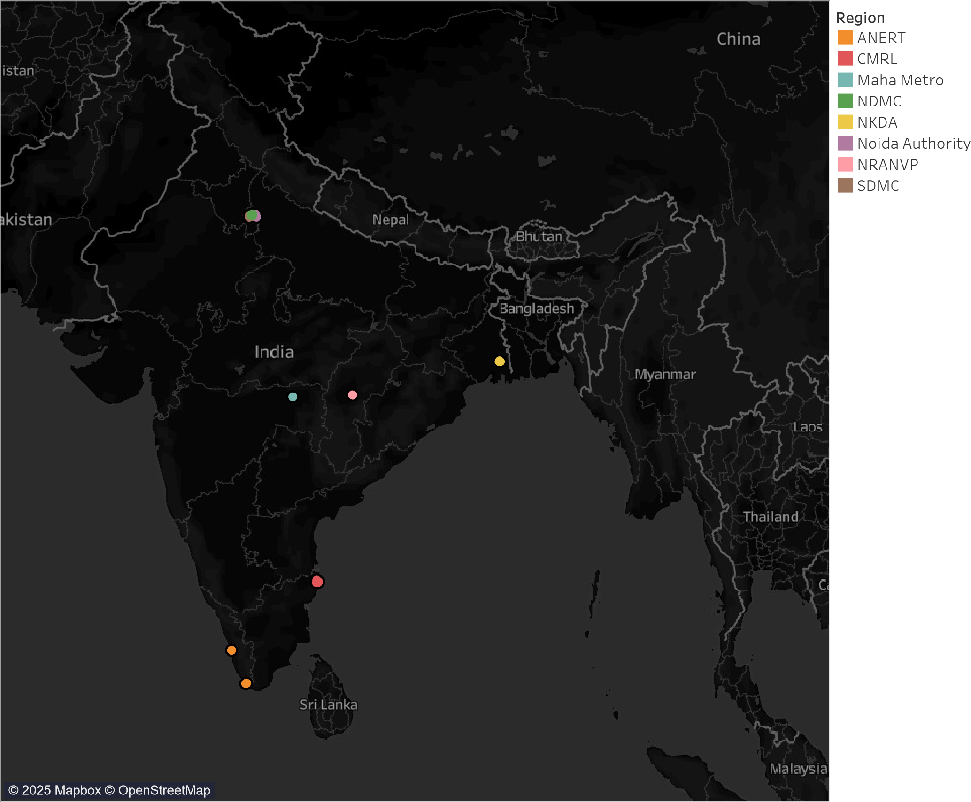
Region
ANERT
CMRL
Maha Metro
NDMC
NKDA
Noida Auth..
NRANVP
SDMC
0
5
10
15
20
25
30
35
40
45
50
55
60
D
i
s
t
i
n
c
t

c
o
u
n
t

o
f

a
u
x

a
d
d
r
e
s
Type
AC-001
CCS/ChADEMO/ ..
DC-001
Car
0
20
40
60
80
100
120
140
160
180
PriceRange(Lakhs)1
Audi E-Tron
Audi E-Tron GT
BMW iX
BYD E6
Hyundai Kona Electric
Jaguar I-Pace
Mercedes-Benz EQC
MG ZS EV
Porsche Taycan
Tata Nexon EV
Tata Nexon EV Max
Tata Tigor EV
Car
Audi E-Tron
Audi E-Tron GT
BMW iX
BYD E6
Hyundai Kona El..
Jaguar I-Pace
Mercedes-Benz E..
MG ZS EV
Porsche Taycan
Tata Nexon EV
Tata Nexon EV M..
Tata Tigor EV
Tata | BYD | Hyundai
 | Jaguar | MG
Audi
 | Mercedes-Benz
BMW | Porsche
Count of Car
03

